Section 1: Populations
Key Ideas
Why is it important to study populations?
What is the difference between exponential growth and logistic growth?
What factors affect population size?
How have science and technology affected human population growth?

Why It Matters
Understanding how populations grow and shrink is critical to managing agricultural pests and diseases and also for knowing how to protect ecosystems.
In the 1850s, about two dozen rabbits from Europe were introduced into Australia. The rabbits had plenty of vegetation to eat, no competition, and no predators. Their numbers increased rapidly. By the 1950s, there were 600 million rabbits! The rabbits ate so much vegetation that the numbers of native plants and animals declined and crops were damaged.

What Is a Population?
As Australia learned, understanding populations is important for protecting ecosystems. A population is made up of a group of organisms of the same species that live together in one place at one time and interbreed. Figure 1 shows members of a zebra population. As new zebras are born, the population size increases. As other zebras fall prey to predators, the population decreases. Hundreds of miles away, there may be another zebra population that lives together and interbreeds.
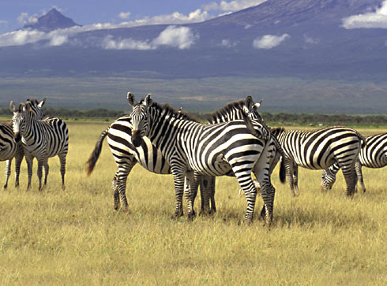

Figure 1 This zebra population lives in Kenya near Mount Kilimanjaro.
Populations can be small or large. Some populations stay at nearly the same number for years at a time. Some populations die out from lack of resources. Other populations grow rapidly, such as the rabbit population in Australia. The rapid growth of the rabbit population caused problems with Australia’s ecosystems, other species, and farmland. Understanding population growth is important because populations of different species interact and affect one another, including human populations. Population Growth
One of the most basic questions ecologists ask is “How do populations grow and shrink?” To help answer this question, biologists make population models. A population model attempts to show key growth characteristics of a real population.

Whether a population grows or shrinks depends on births, deaths, immigration, and emigration. Immigration is the movement of individuals into a population. Emigration is the movement of individuals out of a population. So, a simple population model describes the rate of population growth as the difference between birthrate, death rate, immigration, and emigration. Plotting population changes against time on a graph creates a model in the form of a curve. Two major models of population growth are exponential growth and logistic growth.
Exponential Growth One important part of a population model is the growth rate. When more individuals are born than die, a population grows. In exponential growth, there are always more births than deaths. As time goes by, more and more individuals enter the population. Exponential growth occurs when numbers increase by a certain factor in each successive time period. This type of increase causes the J-shaped curve of exponential growth seen in Figure 2.
Exponential Growth
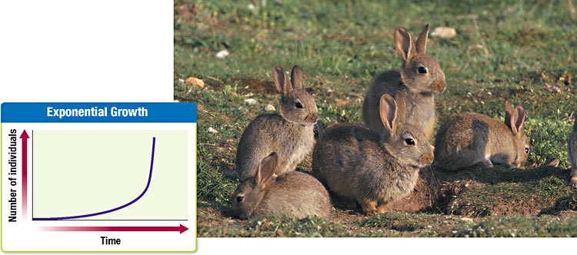

Figure 2 Exponential growth is characterized by a J-shaped curve. Rabbits and bacteria are two examples of populations that can grow exponentially.
In exponential growth, population size grows slowly when it is small. But as the population gets larger, growth speeds up. Bacteria are an example of a population that can grow exponentially. Populations of bacteria grow very fast. A single bacterial cell that divides every 30 minutes will have produced more than 1 million bacteria in 10 hours. Some populations, such as the rabbits shown in Figure 2, may grow exponentially for a while. If they continued to grow exponentially forever, the world would fill up with rabbits!
Logistic Growth Populations do not grow unchecked forever. Factors such as availability of food, predators, and disease limit the growth of a population. Eventually, population growth slows and may stabilize.
An ecosystem can support only so many organisms. The largest population that an environment can support at any given time is called thecarrying capacity. Density-dependent factors are variables affected by the number of organisms present in a given area. An example of a density-dependent factor is the availability of nesting sites. As the number of adult birds increases, there are no longer enough nesting sites for the entire population. So, many birds will not have young, and growth of the population is limited. Density-independent factors are variables that affect a population regardless of the population density. Examples of density-independent factors are weather, floods, and fires.
The logistic model takes into account the declining resources available to populations. Logistic growth is population growth that starts with a minimum number of individuals and reaches a maximum depending on the carrying capacity of the habitat. When a population is small, the growth rate is fast because there are plenty of resources. As the population approaches the carrying capacity, resources become scarce. Competition for food, shelter, and mates increases between individuals of a population. As a result, the rate of growth slows. The population eventually stops growing when the death rate equals the birthrate. On a graph, logistic growth is characterized by an S-shaped curve, as Figure 3 shows. Populations of most organisms, such as the macaws shown in Figure 3, show a logistic growth pattern.
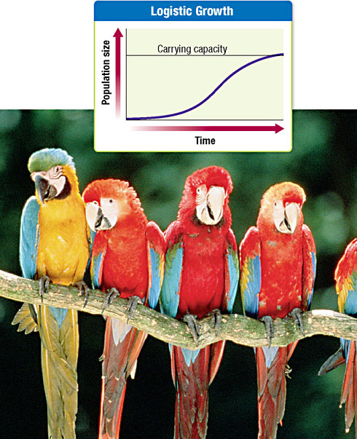
Factors That Affect Population Size
Most populations increase or decrease. Some change with the seasons. Others have good years and bad years. Many factors cause populations to grow and shrink. Water, food, predators, and human activity are a few of many factors that affect the size of a population.
Abiotic Factors Nonliving factors that affect population size are called abiotic factors. Weather and climate are the most important abiotic factors. For example, the population size of the penguins shown in Figure 4 is affected by the climate of Antarctica. Unusually low temperatures can reduce the number of young penguins that survive. The amount of water available can also influence populations. Kangaroo populations in Australia grew when farmers gave water to their livestock that was also available for kangaroos to drink.
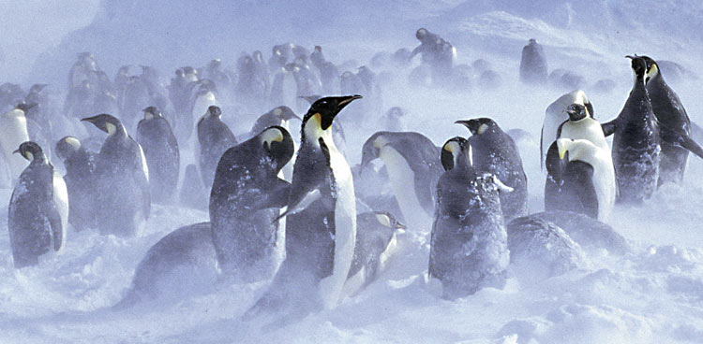

Figure 4 Climate is an abiotic factor that affects the population size of these emperor penguins in Antarctica.
Human Population
Today, the world population is more than 6 billion people and is increasing. Better sanitation and hygiene, disease control, and agricultural technology are a few ways that science and technology have decreased the death rate of the human population. As more humans live on the planet, more resources will be needed to support them. As demand for resources increases, more pressure will be put on Earth’s ecosystems.
Historic Growth For most of human history, there have been fewer than 10 million people. Once agriculture was developed, the population began to grow, but relatively slowly. Two thousand years ago, there were only 10 million people. Around the time of the Industrial Revolution, the human population started to accelerate rapidly. Figure 5 shows the human population accelerating exponentially starting in the late 1700s. Now, there are more than 6 billion people, and some scientists think that the population will grow to 9 billion in 50 years. How many people Earth can support depends in part on science and technology.

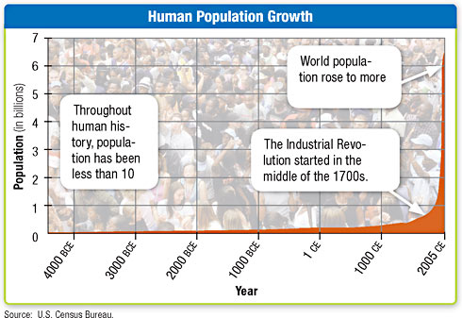

Figure 5 During the last 200 years, the human population has grown exponentially.
Science and Technology Science and technology are major reasons why the human population is growing so rapidly. Advances in agricultural technology have allowed efficient production of crops and other foods. More food supports more people. As a result, the human population has begun to grow faster. Medical advances have also allowed the human population to increase. Vaccines have lowered the death rate. More children are surviving to adulthood. Other medical advances have allowed adults to live longer lives.
Section 2: Interactions in Communities
Key Ideas
How do predator-prey interactions influence both predators and prey?
What are two other types of interaction in a community?

Why It Matters
Interactions between organisms are the basis of communities and are shaped by evolution.
Interactions in communities can take many forms. Predators and prey are locked in a struggle for survival. Organisms with the same needs compete for food. Parasites and hosts try to get ahead of one another. Some organisms even depend on one another for survival.

Predator-Prey Interactions
One of the most common interactions in communities is that between predators and their prey. Predation is the act of one organism killing another for food. As Figure 6 shows, predators try to get a meal, and prey do their best not to become one! We often think of predators as big animals, such as lions chasing zebras or sharks eating fish. Predators come in all sizes. Even microscopic organisms can be predators. In fact, most animals are both predators and prey. Only a few species, such as killer whales, are not hunted by any other animals.
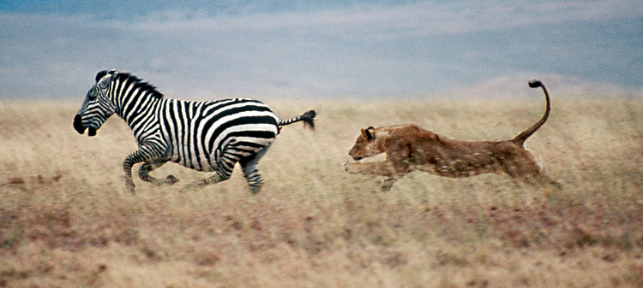

Figure 6 This lion is hoping to have the zebra for lunch.
Many interactions between species are the result of a long evolutionary history. Evolutionary changes in one species can result in changes in another species. Species that involve predator-prey or parasite-host relationships often develop adaptations in response to oneanother. For example, predators evolve to be more cunning to catch their prey. In response, prey evolve to be faster runners to escape more easily. Back-and-forth evolutionary adjustment between two species that interact is called coevolution. Parasitism In parasitism, one organism feeds on another organism called a host. The host is almost always larger than the parasite and is usually harmed but not killed. Parasites often live on or in their host. Therefore, the parasite depends on its host not only for food but for a place to live as well. For example, tapeworms live in the digestive system of their hosts. Fleas that live on the skin of their host are another example.
Hosts try to keep parasites from infecting them. Hosts can defend themselves with their immune systems or behaviors such as scratching. In response, parasites may evolve ways to overcome the host’s defenses.

Herbivory Herbivores are animals that eat plants. Unlike predators, herbivores do not often kill the plants. But plants do try to defend themselves. Some plants have thorns or spines that cause pain for herbivores that try to eat them. Other plants have chemical compounds inside them that taste bad. Some chemical compounds can make an herbivore sick or kill the herbivore.

Some herbivores have evolved ways to overcome plant defenses. For example, monarch butterfly caterpillars feed on milkweed, which is a plant that is toxic to many herbivores. Not only can the caterpillars survive eating the toxic milkweed but the plant toxins then make the monarch butterfly inedible to bird predators.
Other Interactions
Not all interactions between organisms result in a winner and a loser. Symbiosis is a relationship in which two species live in close association with each other. In some forms of symbiosis, a species may benefit from the relationship. Mutualism and commensalism are two kinds of symbiotic relationships in which at least one species benefits.
Mutualism A relationship between two species in which both species benefit is called mutualism. Some shrimp and fishes on coral reefs clean the bodies of large fish and turtles. The cleaners even venture into the mouths of big predators that could easily swallow them, asFigure 7 shows. Why don’t the cleaners become an easy meal? The reason is that the big fish is having parasites removed by the cleaner. Because the cleaner gets a meal, both species win.
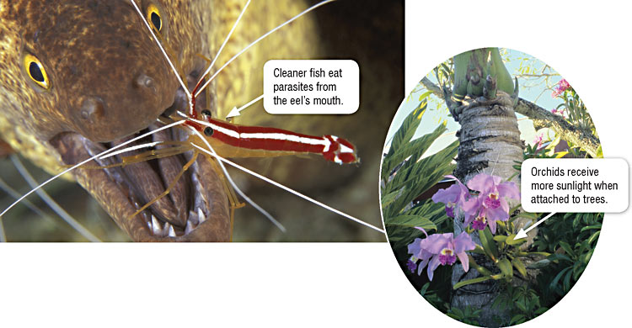
Section 3: Shaping Communities
Key Ideas
How does a species’ niche affect other organisms?
How does competition for resources affect species in a community?
What factors influence the resiliency of an ecosystem?

Why It Matters
The interactions among organisms in communities shape the ecosystem and the organisms that live there.
No organism can live everywhere. Each organism has its own set of conditions where it can live and where it does best. Some plants, such as cactuses, can survive in deserts, but other plants need a lot of water. The desert plants cannot live in areas that have a lot of water because other plants outcompete them.

Carving a Niche
Think of your favorite plant or animal. How does it use the physical environment? How does it interact with other species? The unique position occupied by a species, both in terms of its physical use of its habitat and its function in an ecological community, is called a niche. A niche is not the same as a habitat. A habitat is the place where an organism lives. A niche includes the role that the organism plays in thecommunity. This role affects the other organisms in the community. For example, the beaver shown in Figure 8 cuts down trees with its sharp teeth. The beaver then uses the trees to make dams that divert, or redirect, water flow in rivers and streams. These actions directly affect the trees by killing the trees. These actions also affect organisms that depend on the trees for shelter or food. However, some plants would benefit: fewer trees would allow the plants access to more sunlight. Diverting water flow in a stream could be beneficial to some forms of aquatic life. For others, a dam in a stream could prevent them from traveling upstream to mating grounds. The beaver’s role affects many other organisms. If you took the beaver out of this ecosystem, the community would be very different.
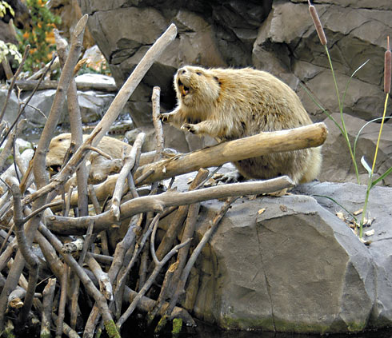

Figure 8 Beavers build dams from trees and tree branches that they cut with their sharp, powerful teeth.
Competing for Resources
The entire range of conditions where an organism or species could survive is called its fundamental niche. Many species share parts of their fundamental niche with other species. Sometimes, species compete for limited resources. Because of this competition, a species almost never inhabits its entire fundamental niche. Competition for resources between species shapes a species’ fundamental niche. The actual niche that a species occupies in a community is called its realized niche.
Sometimes, competition results in fights between rivals. Hyenas and lions will even steal food from one another. The stealing of food is calledkleptoparasitism. Many competitive interactions do not involve direct contests. But when one individual takes a resource, the resource is no longer available for another individual. Many plants compete fiercely for access to light. Some do so by growing quickly to get above other plants. Other plants can tolerate periods of shade and grow slowly. As the slow-growing plants become larger, they eventually shade out other plants.

Competition has several possible outcomes. Sometimes, one species wins, and the other loses. The loser is eliminated from the habitat. Other times, competitors can survive together in the same habitat. They are able to survive together because they divide the resources.
Competitive Exclusion No two species that are too similar can coexist. Why? If species are too similar in their needs, one will be slightly better at getting the resources on which they both depend. The more successful species will dominate the resources. The less successful species will either die off or have to move to another ecosystem. Eventually, the better competitor will be the only one left. One species eliminating another through competition is called competitive exclusion.
Competitive exclusion is seen in many places. When there are no predators around, mussels take over all of the space on rocks in the surf zone. The mussels eliminate barnacles from the surf-zone rocks that are part of the mussels’ fundamental niche. Introduced species can also competitively exclude native species. When introduced species multiply quickly, they can use up all of the available resources. When resources are used up, other species that depend on the resources may become extinct.
Dividing Resources Sometimes, competitors eat the same kinds of food and are found in the same places. How do these species live together? Some competitors divide resources by feeding in slightly different ways or slightly different places. The five warblers shown inFigure 9 are all potential competitors. All five species feed on insects in the same spruce trees at the same time. But they divide the habitat so that they do not compete. Each species feeds in a different part of the tree. Every one of the warbler species would feed everywhere in the tree if it had the tree to itself. Therefore, all the warbler species have the same fundamental niche. But when they are all present in the tree, they each have a smaller realized niche.
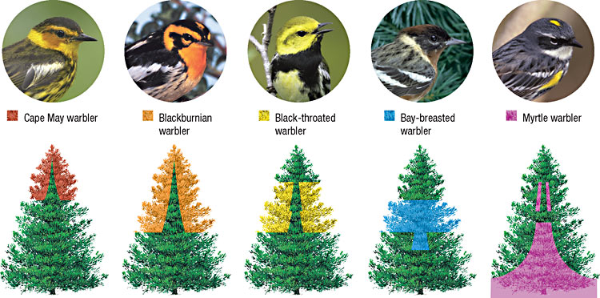
Ecosystem Resiliency
Ecosystems can be destroyed or damaged by severe weather, humans, or introduced species. Some factors can help keep an ecosystem stable. Interactions between organisms and the number of species in an ecosystem add to the resiliency of an ecosystem.
Predation and Competition Predation can reduce the effects of competition among species. Many aquatic species compete for space in the intertidal zone along the Pacific coast. Mussels are fierce competitors that can take over that space. All other species are excluded. However, sea stars eat mussels. When sea stars eat the mussels, a variety of species can live in the intertidal zone.
Predators can influence more than their prey. Sea otters, as shown in Figure 10, eat sea urchins. Sea urchins eat kelp. When sea otters are present, lush kelp forests grow along the west coast of North America. These kelp forests provide habitat for many fishes and aquatic animals. When sea otters disappeared because of overhunting, the sea urchins ate all of the kelp. All of the species that depended on the kelp also disappeared. Sea otters are an example of a keystone species. A keystone species is a species that is critical to an ecosystem because the species affects the survival and number of many other species in its community.
