Section 3: Cycling of _____________________
Key Ideas
What is the _____________________cycle?
Why are plants and animals important for carbon and oxygen in an ecosystem?
Why must nitrogen cycle through an ecosystem?
Why must _____________________cycle through an ecosystem?

Why It Matters
Water, carbon, phosphorus, and nitrogen are _____________________resources for organisms, including _____________________. Natural cycles of these resources are important to ecosystems, but humans can disrupt these cycles.
Water, carbon, oxygen, _____________________, and phosphorus are five of the most important _____________________for life. An ecosystem must be able to cycle these kinds of matter in order to support life.

Water Cycle
Life could not exist without the water cycle. The water cycle _____________________moves water between the atmosphere, the land, and the oceans. As Figure 9 shows, water vapor _____________________and falls to Earth’s surface as _____________________. Some of this water _____________________into the soil and becomes groundwater. Other water runs across the surface of Earth into rivers, lakes, and oceans. Then, the water is heated by the sun and reenters the _____________________by _____________________. Water also evaporates from trees and plants in a process called _____________________.
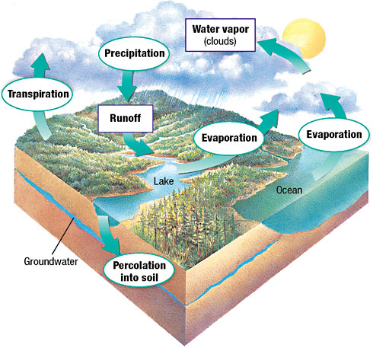
Carbon and Oxygen Cycles
Carbon and oxygen are critical for life on Earth, and their cycles are tied closely together. The carbon cycle is the continuous movement of carbon from the nonliving environment into living things and back. The carbon cycle is shown in Figure 10.
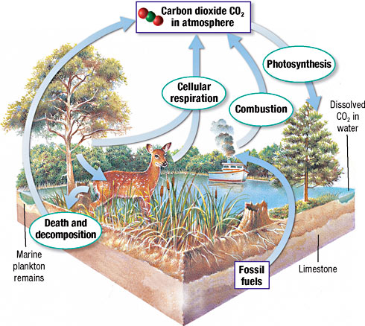
Nitrogen Cycle
All organisms, including you, need _____________________. Nitrogen must be _____________________through an ecosystem so that the _____________________is available for organisms to make _____________________. The nitrogen cycle is the process in which nitrogen circulates among the _____________________, soil, water, and _____________________in an ecosystem. The nitrogen cycle is shown in Figure 11.
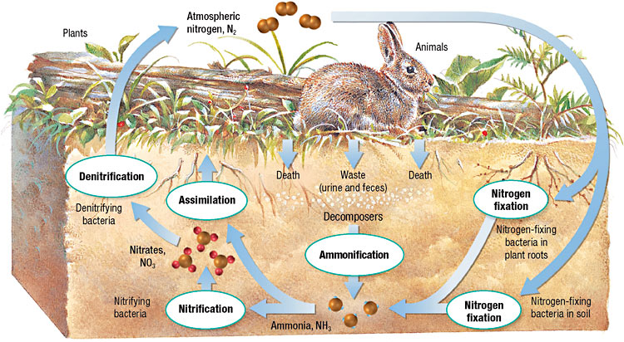

Figure 11 Bacteria carry out many of the important steps in the nitrogen cycle, including the conversion of atmospheric nitrogen into a usable form, such as ammonia.
The _____________________is about 78% nitrogen gas, N₂. But most _____________________cannot use nitrogen gas. It must be changed into a different form. A few bacteria have enzymes that can break down N₂. These _____________________supply the nitrogen that all other organisms need. The bacteria split N₂ and then bind nitrogen atoms to hydrogen to form ammonia, NH₃. The process of combining _____________________with _____________________to form ammonia is callednitrogen fixation. Nitrogen may be fixed by lightning. But more nitrogen is fixed by bacteria. Nitrogen-fixing bacteria live in the soil and on the roots of some plants. Nitrogen is also fixed when humans burn fuels in _____________________and industrial plants.
Plants get _____________________by assimilation. _____________________is the process in which plants absorb nitrogen. When an animal eats a plant, nitrogen compounds become part of the animal’s body. During _____________________, nitrogen from animal waste or _____________________bodies is returned to the soil by bacteria. Ammonia is then converted to nitrite and then nitrate by the process of _____________________. Finally, in denitrification, nitrate is changed to nitrogen gas, N₂, which returns to the atmosphere.
Phosphorus Cycle
_____________________is an important part of ATP and DNA and must be cycled in order for an ecosystem to support life. The phosphorus cycle is the movement of phosphorus in different chemical forms from the surroundings to organisms and then back to the surroundings. Phosphorus is often found in soil and rock as calcium phosphate, which _____________________in water to form phosphate. The _____________________of plants absorb phosphate. Humans and animals that eat the plants reuse the organic phosphorus. When the humans and animals die, phosphorus is returned to the soil.

