Section 1: What Is an _________________?
Key Ideas
What are the parts of an ecosystem?
How does an ecosystem _____________________to change?
What two key factors of climate determine a biome?
What are the three major groups of _____________________biomes?
What are the four kinds of aquatic _____________________?

Why It Matters
Ecosystems are important units of the natural world. Humans are part of ecosystems and depend on ecosystems for food and many products. Without healthy ecosystems, humans would be in trouble!
When you walk through a _____________________, you see many different organisms. There are trees, birds, ants, mushrooms, and much more. You may not see many of these organisms interact. But all organisms, including humans, that live together are _____________________.

Ecosystems
A species never lives alone. A group of various species that live in the same place and interact with one another is called a ____________________. The group, along with the living and nonliving environment, make up an ecosystem. An ecosystem includes a community of organisms and their physical environment.
Community of _____________________A community of _____________________ is a web of relationships. One relationship is that of a predator eating its prey. For example, some fish eat spiders, as Figure 1 shows. Some _____________________help each other. For example, some bacteria fix nitrogen into a form that plants can use to grow. _____________________between organisms are examples of biotic factors that affect an ecosystem. _____________________describes living factors in an ecosystem. Biotic factors also include once-living things, such as dead organisms and the waste of organisms.
Physical Factors The _____________________or nonliving factors of an environment are called _____________________factors. Examples of abiotic factors are _____________________, water, rocks, sand, sunlight, temperature, and climate. These physical factors shape organisms. For example, plants and _____________________in deserts are small because deserts do not have enough water to support large organisms. Water supply also affects the _____________________of individuals and _____________________of species that an ecosystem can support. A crop of corn will have a higher yield in a wetter habitat than in a drier habitat. A habitat is the place where an organism lives.
Biodiversity _____________________you counted the various species in a pine forest. Then, you counted the number of species in a tropical rain forest. Do you think the number of species in each _____________________would be the same? No, a tropical rain forest has many more species than a pine forest does. The variety of organisms in a given area is called biodiversity.
_____________________factors can have a big influence on _____________________. In places that have very high or very low temperatures, biodiversity is often lower. Limited water and food also cause lower biodiversity. The biodiversity of habitats and ecosystems varies greatly. The vast expanse of the open ocean has very low biodiversity. In contrast, rain _____________________and coral reefs have very high _____________________. When ecosystems have high biodiversity, they are often more able to resist damage. Damage to ecosystems can be caused by severe weather events or human activities. Systems with low biodiversity can be severely damaged easily. When biodiversity _____________________in any ecosystem, that ecosystem is not as healthy as it could be.
Succession
When we observe an ecosystem, it may look like an _____________________feature of the _____________________. However, all ecosystems change. As an ecosystem changes, the kinds of species that the ecosystem supports change. The _____________________of one community by another at a single place over a period of time is called succession.
_____________________in an Ecosystem When a _____________________forms a new island or a fire burns the vegetation of an area, new opportunities are made for organisms. The first _____________________to appear in a newly made habitat are called _____________________species. Pioneer species are often small, fast-growing plants that reproduce quickly. They change the habitat in such a way that other species can live in the ecosystem. For example, pioneer species such as _____________________and mosses will break _____________________volcanic rock on a new island to help form soil. Other species can then grow on the soil. For example, after lichens and mosses have formed soil, grasses and _____________________may then cover a volcanic island. Even later, shrubs and trees often outcompete and replace the grass. Then, the _____________________turns into a forest. Figure 2 shows an example of succession in response to the _____________________of a glacier.

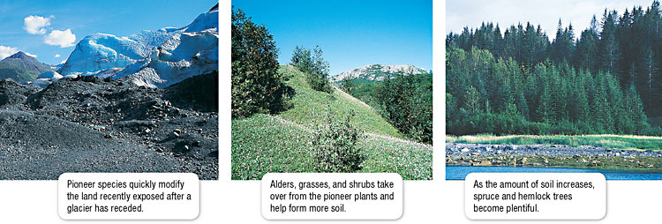

Figure 2 At Glacier Bay in Alaska, a receding glacier makes succession possible.
_____________________If a major disruption strikes a _____________________, many of the organisms may be _____________________out. But the ecosystem reacts to the change. An ecosystem responds to change in such a way that the _____________________is restored to equilibrium. When a tree falls down in a rain forest, for example, the newly vacant patch proceeds through succession until the patch returns to its original state. Sometimes, the ecosystem will find an equilibrium in which different species dominate after a change. In the grasslands of _____________________, for example, weather conditions can lead to _____________________. When there is a lot of rain in the _____________________, one species of grass dominates the savanna. But when conditions are drier, a drought-resistant species of grass will _____________________.
Major Biological Communities
If you drive across the United _____________________, you notice a change in the kinds of plants and animals. The kinds of species that live in a particular place are _____________________partly by climate. _____________________is the average weather conditions in an area over a long period of time. At places near the _____________________Pole, you may see polar bears. Polar bears have thick, white fur and insulating fat that keep them warm on the _____________________tundra. The same adaptations that help polar bears in the tundra would hurt polar bears in a tropical forest. _____________________bears must live in a biome to which they are adapted. A biome is a large region characterized by a specific kind of _____________________and certain kinds of plant and animal communities.
_____________________key factors of climate that determine biomes are temperature and precipitation. Most organisms are adapted to live within a particular range of temperatures and cannot survive at _____________________too far above or below that range. _____________________also determines the kinds of species that are found in a biome. In biomes where precipitation is low, for example, the _____________________is made up mostly of _____________________that need little water, such as cactuses.
Terrestrial _____________________
There are many different biomes on land. Earth’s major terrestrial biomes can be grouped by latitude into _____________________, temperate, and high-latitude biomes. As Figure 3 shows, tropical biomes are generally near the _____________________. For the most part, temperate biomes are between 30º and 60º latitude. High-latitude biomes are at latitudes 60º and higher. _____________________affects the amount of solar energy that a biome receives and thus affects a biome’s temperature range.
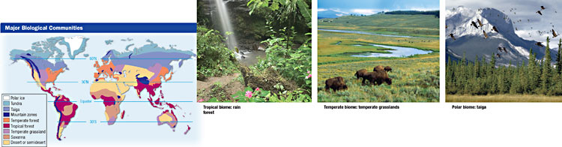
_____________________Biomes Because they are located at low _____________________near the equator, all tropical biomes are warm. However, each tropical biome receives a different amount of rain. _____________________rain forests receive large amounts of _____________________and are warm all year. They have the greatest _____________________of any land biome. At least half of Earth’s species of land organisms live in tropical rain forests. Savannas are _____________________grasslands. They get less rain than tropical rain forests do. Savannas also have long dry seasons and _____________________wet seasons. The most wellknown savannas are in eastern Africa, where zebras, giraffes, lions, and elephants roam the grasslands. Tropical deserts get very little rain. Because the _____________________have less water, they have fewer plants and animals than other biomes do.

_____________________Biomes Biomes at mid-latitudes have a wide range of temperatures throughout the year. Temperate grasslands have moderate precipitation and cooler temperatures than savannas do. _____________________grasslands are often highly productive when used for agriculture. Herds of _____________________animals, like bison, used to live on the temperate grasslands of North America. Temperate forests grow in mild _____________________that receive plenty of rain. Trees of the temperate deciduous forests shed their leaves in the fall because of the cold winters. Trees of temperate _____________________forests do not lose their leaves or needles during the winter. Temperate forests are home to deer, bears, beavers, and _____________________. Like tropical deserts, temperate deserts receive little precipitation. However, _____________________tropical deserts, temperate deserts have a wide temperature range throughout the year.

_____________________ Biomes Biomes at high latitudes have cold _____________________. Coniferous forests in cold, wet climates are called taiga. Winters are long and cold. Most of the precipitation falls in the _____________________. Moose, _____________________, and bears live in the taiga. The tundra gets very little rain, so plants are short. Much of the water in the soil is not available because the water is frozen for most of the _____________________. Foxes, lemmings, owls, and caribous live in the tundra.

Aquatic Ecosystems
The diverse regions in the world’s _____________________of water are not usually called _____________________. They are often called aquatic ecosystems. Aquaticecosystems are organized into freshwater _____________________, wetlands, estuaries, and marine ecosystems.
Freshwater _____________________are located in bodies of fresh water, such as lakes, ponds, and rivers. These ecosystems have a variety of plants, fish, _____________________, mollusks, and other invertebrates.

_____________________provide a link between the land and fully aquatic _____________________. Water-loving plants dominate wetlands. This ecosystem supports many species of birds, fishes, and plants, as shown in Figure 4. Wetlands are important because they moderate flooding and _____________________the water that flows through them.

