Name___________________________

Modeling the Cell Membrane

The job of the cell membrane is to both separate the cell from what surrounds it and, most importantly, control what is able to enter and exit the cell. The cell membrane is selectively permeable meaning that only some things are able to enter and leave the cell easily. Passive transport happens without the cell needing to use any energy to move things through the membrane. Active transport needs some energy to move things through the membrane. The cell membrane is made up of phospholipids where part is hydrophilic (water-loving) and part is hydrophobic (water-repelling). This causes the phospholipids to be arranged in a very specific way with the hydrophobic tails facing inward and the hydrophilic heads facing outwards. In this activity the Q-tips represent the phospholipids. However, one Q-tip equals two phospholipids (see figure 1).

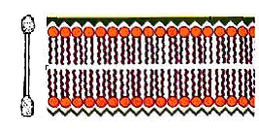Fig. 1

The membrane also has proteins imbedded in the membrane. Some proteins are simple channel proteins while others are receptor proteins. There are two types of receptor proteins- an intracellular receptor and an external membrane receptor. The intracellular receptor connects the inside and outside of the cell while the membrane receptor attaches to the outside of the cell. The external membrane receptors bind to a molecule and send a message to the inside of the cell. The entire receptor changes shape and a chain of events follows that tells the cell what to do. Today you are going to make two different models of the cell membrane

Part 1: Modeling the Cell Membrane

Purpose: How does the cell membrane regulate what moves into and out of the cell?

Materials: 50 Cotton Swabs
1 Rubber Band
2 Pipe Cleaners of different colors
1 Drinking Straw
Scissors

Pre-lab: List the molecules that make up the cell membrane:

Procedure:
- Bundle the swabs together and wrap the rubber band around them tightly.
- Make a receptor from one pipe cleaner. It should extend through the bunch of swabs and have a region than would bind to a signal molecule. Use the other pipe cleaner to make another receptor protein.
- Cut the drinking straw in half and insert both halves into the bunch of swabs.

Questions:
- Draw your model here.

What does the drinking straw represent?

- How do the swabs represent the polar and non-polar characteristics of the cell membrane? Which part is hydrophobic and which part is hydrophilic?

- In this model, the swabs and proteins can be moved around. Explain whether this is an accurate representation of actual cell membranes.

Part 2: Modeling Active and Passive Transport

Purpose: Demonstrate how active and passive transport work in a a selectively permeable
membrane.

Materials: 4 jumbo craft sticks
Marker
Glue gun
Rubber Bands
Ping-pong ball
Marbles

Procedure:
- Glue four of the craft sticks together to make a square.
- Wrap 5 elastic bands horizontally around Popsicle stick square. Wrap another 5 bands vertically around square, making a ¾ of an inch grid inside of the square.

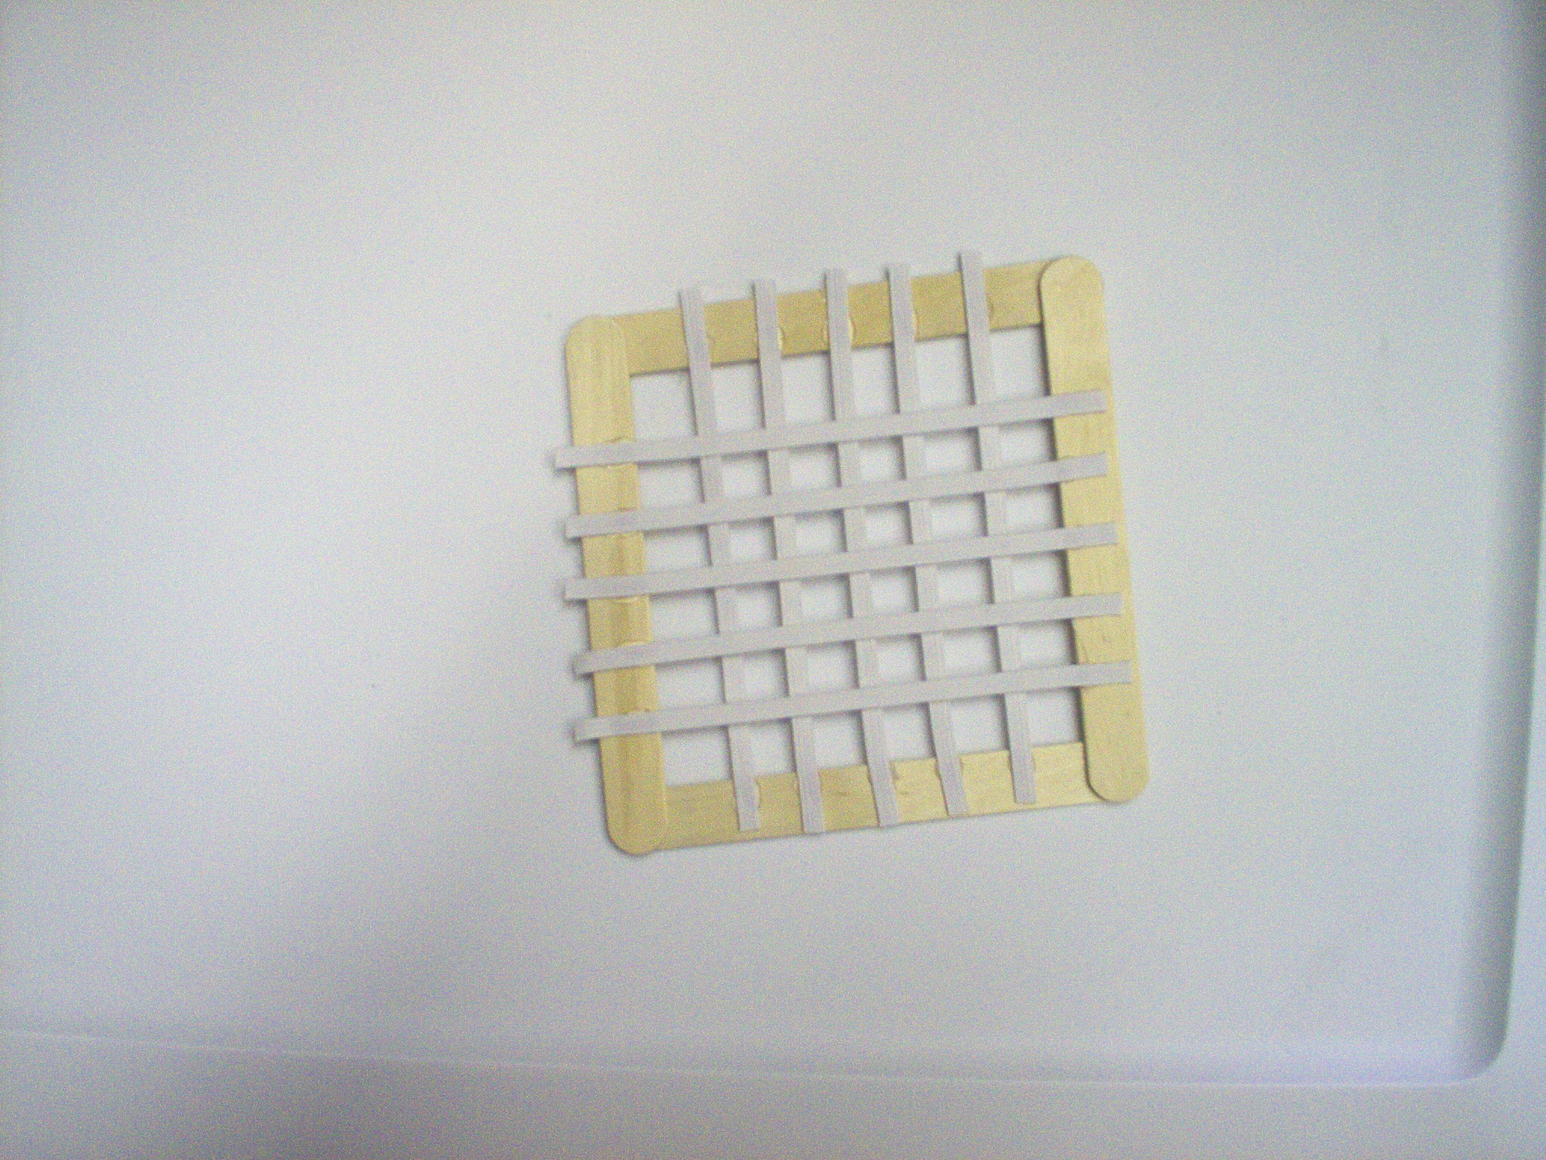

- Now try and drop the marbles through your model plasma membrane. Record what happens in the table.
Now, try and drop the ping-pong ball through the model plasma membrane. Record what happens in the table.
- Choose 3 more items from the box at the front of the classroom and determine if they require energy to move through the membrane. Record the data in the table.

Results:

Item Name | Observations | Energy required? (Yes/No) | Type of transport (Active/ Passive)

Questions:
- What size items passed through the membrane without energy? Why?

- What size items passed through the membrane with energy? Why?

- What function of a plasma membrane does this model show?

- How does a selectively permeable membrane help maintain homeostasis?

