Chapter 5 Summary and Vocabulary
(p.118)

Key Ideas
Section 1: Populations

Understanding population growth is important because populations of different species interact and affect one another, including human populations.
Exponential growth occurs when numbers increase by a certain factor in each successive time period. Logistic growth is population growth that starts with a minimum number of individuals and reaches a maximum depending on the carrying capacity of the habitat.
Water, food, predators, and human activity are a few of many factors that affect the size of a population.
Better sanitation and hygiene, disease control, and agricultural technology are a few ways that science and technology have decreased the death rate of the human population.

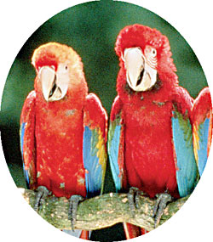

Population
Carrying capacity

Section 2: Interactions in Communities

Species that involve predator-prey or parasite-host relationships often develop adaptations in response to one another.
Mutualism and commensalism are two types of symbiotic relationships in which one or both of the species benefit.

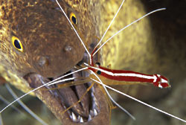

Predation

Coevolution

Parasitism

Symbiosis

Mutualism

Commensalism

Section 3: Shaping Communities

A niche includes the role that the organism plays in the community. This role affects the other organisms in the community.
Competition for resources between species shapes a species’ fundamental niche.
Interactions between organisms and the number of species in an ecosystem add to the stability of an ecosystem.

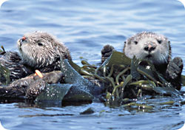

Niche

Fundamental niche

Realized niche

Competitive exclusion

Keystone species

